**Athabasca GPR ice thickness processing** 03 June 2019

William Armstrong

Please read this document in full before beginning any work.

**End products**

We are working towards the following items. These data will be used for modeling glacier flow and for siting boreholes to the glacier bed.

1) A spatially referenced (i.e., x/y coordinates are latitude/longitude) map of the glacier ice surface elevation (from survey-grade GPS where possible).

2) A spatially referenced (i.e., x/y coordinates are latitude/longitude) map of ice thickness (from digitizing radar grams and raw waveforms).

3) A spatially referenced (i.e., x/y coordinates are latitude/longitude) map of the glacier bed elevation (item 1 minus item 2).

The figure below shows our spring GPR data collection (using handheld GPS coordinates).

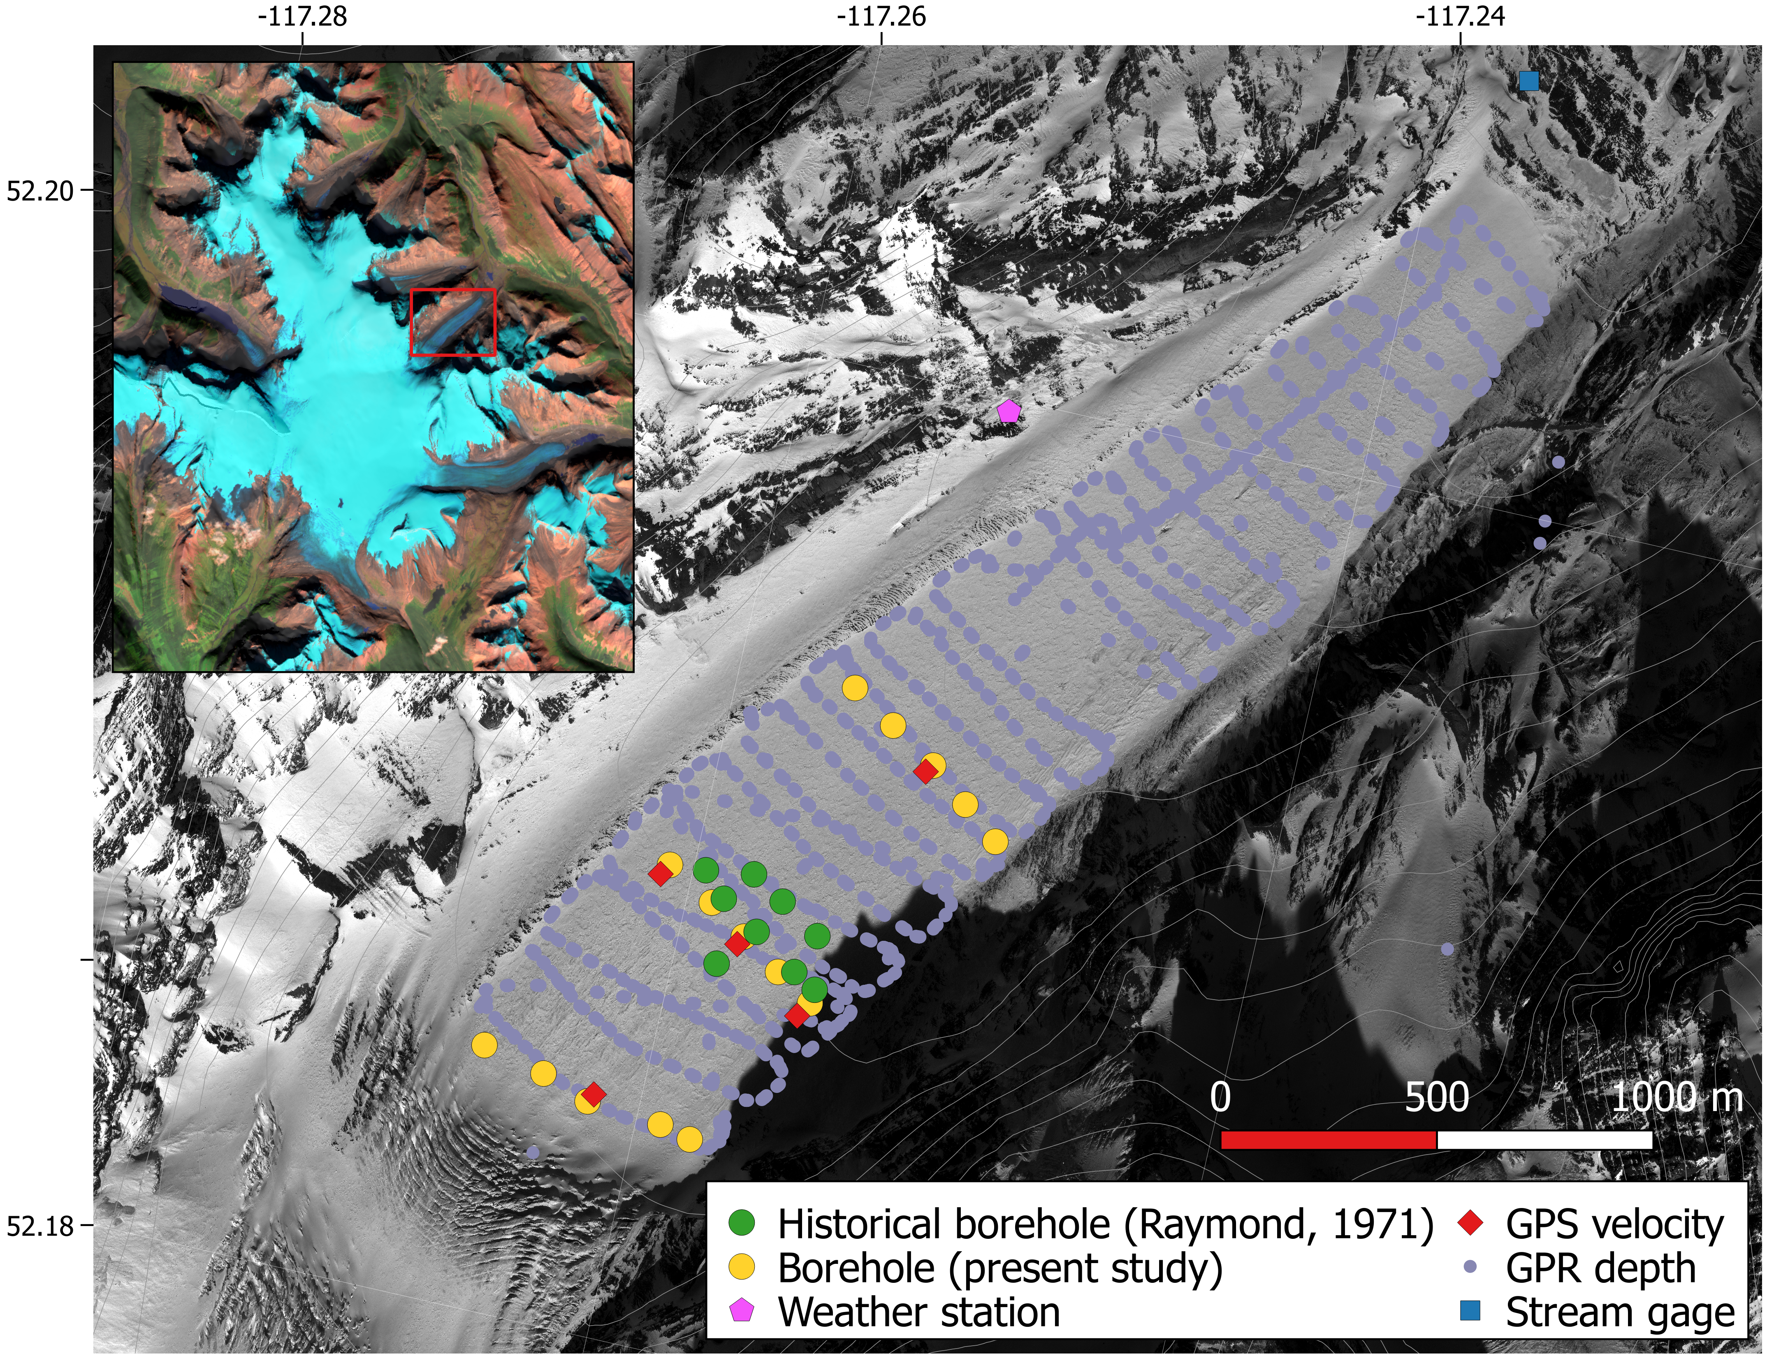

We want to be able to produce a map like that shown below for Kennicott Glacier (though with much better spatial resolution).

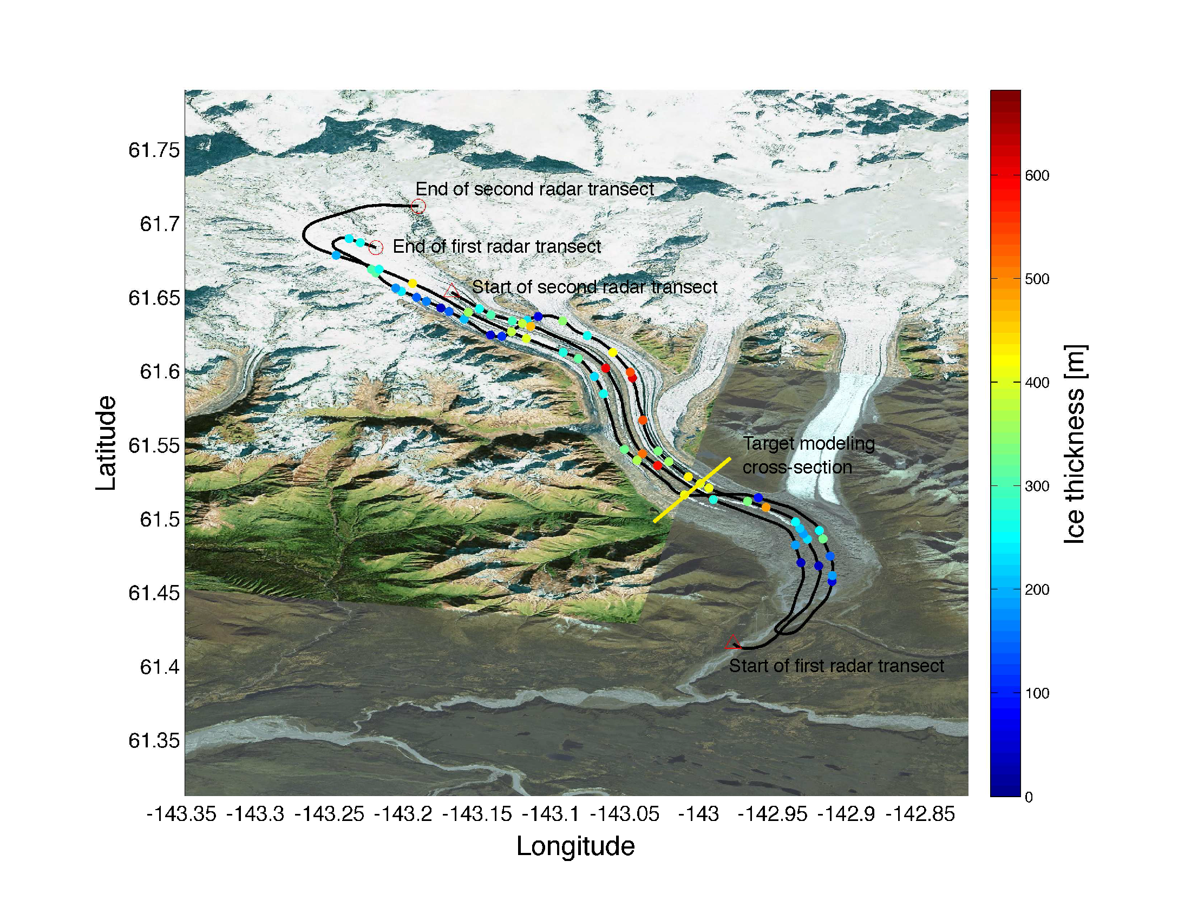

**General workflow**

*Bedrock digitization*

1) Digitize depth to bedrock for each profile from radargrams (i.e., gray plots with shot number as x-axis and depth below surface as y-axis).

Use digitizeRadagram.m to do this. The process is based on the Matlab function ginput which records cursor click locations. This script will automatically save click locations in a new recDigitize file contained in the .mat output.

2) Create plots showing bed picks on top of radargram (this is an output from digitizeRadargram.m)

3) Refine depth to bedrock by picking bed return from raw waveform.

Wait on this step until we have a script from Martin.

*Position determination*

4) The handheld GPS data were collected at irregular intervals and do not precisely correspond to the points where radar waveforms were collected. Interpolate rec.long, rec.lat, rec.time to even spacing using Matlab function interp1. See figure below for what we’re trying to do here.

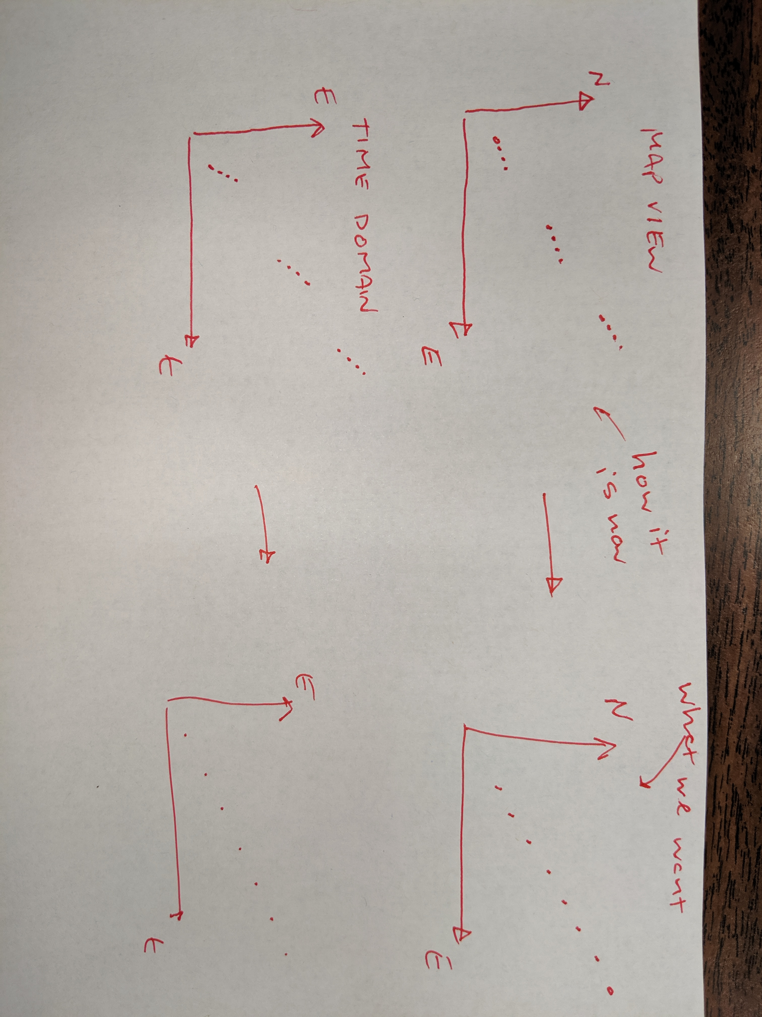

5) Use interpolated rec.time to find closest survey grade GPS observation in ath<xxxx>.csv files in /gps/csrs/ folder.

ind = min(find(timeSurvey>=timeHandheld))will be a useful index for finding these locations. You can use this index to pull GPS coordinates.

6) Update recDigitize file with new variables recDigitize.surveyLong, .surveyLat, .surveyTime, .surveyElev that contain the high accuracy position determinations. Save these files to the drive folder.

**Importantly**, these positions vectors should have element numbers that corresponds with the rec.long, etc. files. This will make it easier to keep track of which handheld GPS positions became which survey-grade GPS positions, and will make giving bed picks spatial coordinates much easier.

7) Make and save map-view plots showing the original rec.lat, etc. coordinates and the updated rec.surveyLat coordinates (plot on sam\e figure to facilitate comparison).

8) We should now have the data required to make a surf3 plot showing the x,y,z coordinates (easting, northing, height) of the glacier surface and glacier bed. Create and save this plot.

*Interpolating bed map*

9) We want to know how thick the ice is between our radar soundings. To do this, we will need to run two-dimensional interpolation.

This may involve kriging or some kind of anisotropic interpolation that honors the fact that glacier ice thickness may be more similar to that seen at a transect 100 m up-glacier than a point 100 m cross-glacier towards the glacier margin. We’ll figure out more details on this when the time approaches.

**Note taking**

These data will be used by other researchers in the future. You may also use these data 6 months from now and not recall your process. Therefore, *you must take very detailed notes throughout your digitizing process*.

For each profile, note:

- Any regions of “missing” or very weak bed returns. Provide shot number location range.

- Any regions of ambiguous bed returns. Provide shot number location range.

- Any peculiarities you see – e.g., “bowties”, crossing lines, etc. Provide show number location range.

- Any “judgement calls” you made. Provide justification.

Provide a written log of any decisions or judgement calls you make throughout this process. We will have to justify your decisions in future peer-reviewed publications. Being detailed and well-documenting your decision process now will save many future headaches.

*Write documentation* that describe your digitization procedure in a way a future researcher could replicate. Include names of scripts used. Include values for parameters used. Put into words any criteria you use for guiding your decision making. Save plots to record a paper trail of your work. For example, output a plot (save as .pdf) showing the radargram and your bed picks for each profile.

**Data**

All scripts and data can be found in a zip file in our shared Google Drive folder.

**Scripts**

digitizeRadargram.m – use this script for digitizing radargrams. Runs ginput, which records locations of clicks on a figure. Press enter after you’ve finished digitizing that profile.

readwv.m – this script reads raw waveform files and outputs a rec file as a .mat file

processRadarData.m – this script does gain correction and automatically plots radargrams. Outputs the *_gain.mat files.

**Radar**

.mat files

Each profile mat file includes a rec variable (or maybe recSine or recDigitize) that contains information about the profile. The structure of these files is:

rec.lat = latitude at each radar sounding (i.e., one depth measurement, one waveform). This is coarse accuracy, need to update with survey grade GPS.

rec.lon = longitude at each sounding. This is coarse accuracy, need survey grade GPS.

rec.elev = elevation at each sounding. This is coarse accuracy, need survey grade GPS.

rec.time = time sounding was made.

rec.wvExp = radargram with an exponential gain correction

rec.wv = raw radargrams

**GPS**

Handheld

In profile rec variable.

Survey grade

*Notes:*

File naming convention: ath<DOY><SURVEY_NUM> where DOY is the day of year (where DOY 1 = Jan 1, DOY 365 = Dec 31); SURVEY_NUM is the sequential survey number that was run on that DOY.

Some files contain multiple cross-glacier transects, others contain just one profile.

The clock for GPS observations is in coordinated universal time (UTC). To convert to local time in Alberta (Mountain time), subtract 7 hours for standard time (i.e., not daylight savings, which did not take affect until Mar 10 after we were off the glacier). It is best to just leave things in UTC – I only state this time difference in case the handheld GPS has a different time reference. Martin’s gear could be set to AK time too, which would be UTC - 9.

It looks like there are some times that the GPS lost satellites (missing positions, e.g. ath0651 at start). We’ll have to just use the hand-held GPS coordinates at these times.

*CRSS*

ath<xxxx>.pdf – summary file showing plots of satellite positions, antenna coordinates, and data quality during the transect.

ath<xxxx>.csv – a text file containing antenna coordinates. This will be your main file to work with. There is a header that explains what each column represents.

ath<xxxx>.sum – summary text file describing the survey. Probably not very useful.

Converting between lat/lon & UTM

You may have to convert between WGS84 (latitude and longitude) to UTM. UTM is a coordinate system that uses meters for horizontal units and is better for small scale mapping like we are doing. Below are Matlab functions to facilitate these coordinate transforms. Athabasca is in UTM zone 11N.

<https://www.mathworks.com/matlabcentral/fileexchange/10915-deg2utm>

<https://www.mathworks.com/matlabcentral/fileexchange/10914-utm2deg>

Acronyms you may see

SV = space vehicle (a satellite); NSV = number of space vehicles – the more the better

GDOP = geometric dilution of precision (position accuracy metric)

epoch = <https://gis.stackexchange.com/questions/281223/what-is-a-gps-epoch>

DOY = day of year, where DOY 1 = Jan 1, DOY 365 = Dec 31 (for a non-leap year)

UTC = coordinated universal time, same as Greenwich mean time without daylight savings

MST = mountain standard time – time zone for Alberta during our field work

UTM = universal transverse Mercator – a projection that uses meters for horizontal units instead of degrees that is better for small scale mapping like we are doing